Project Development Phase
Model Performance Test

Date | 7 February 2026
Team ID | LTVIP2026TMIDS24589
Project Name | Project -  Plugging into the Future: An Exploration of  Electricity Consumption Patterns Using Tableau
Maximum Marks

Model Performance Testing:
Project team shall fill the following information in model performance testing template.

S.No. | Parameter | Screenshot / Values
1. | Data Rendered | https://drive.google.com/file/d/1JxIkHNwXxjFztKq7ad0_Ktk ukCqTckNy/view?usp=sharing
2. | Data Preprocessing | 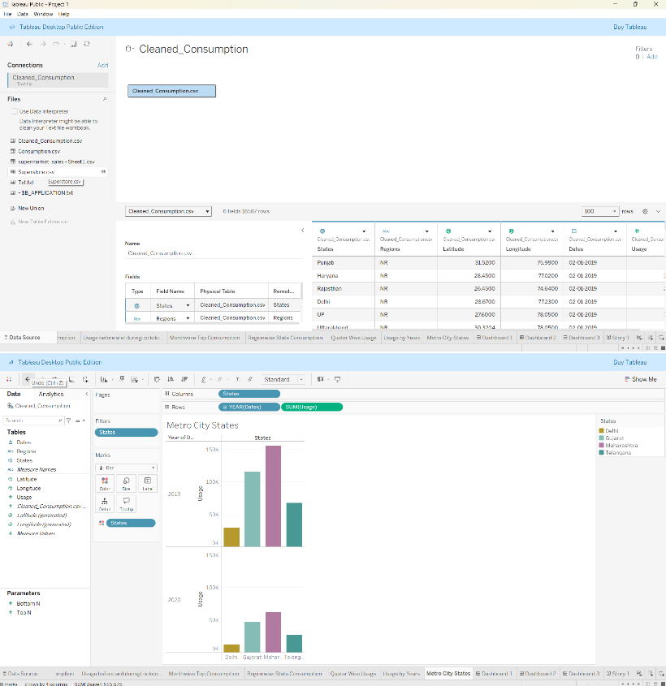
3. | Utilization of Filters
4. | Calculation fields Used | 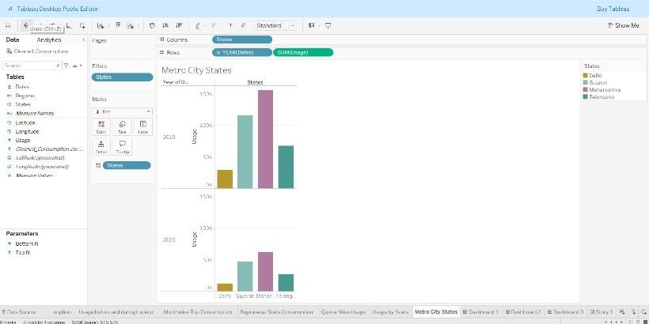
5. | Dashboard design | 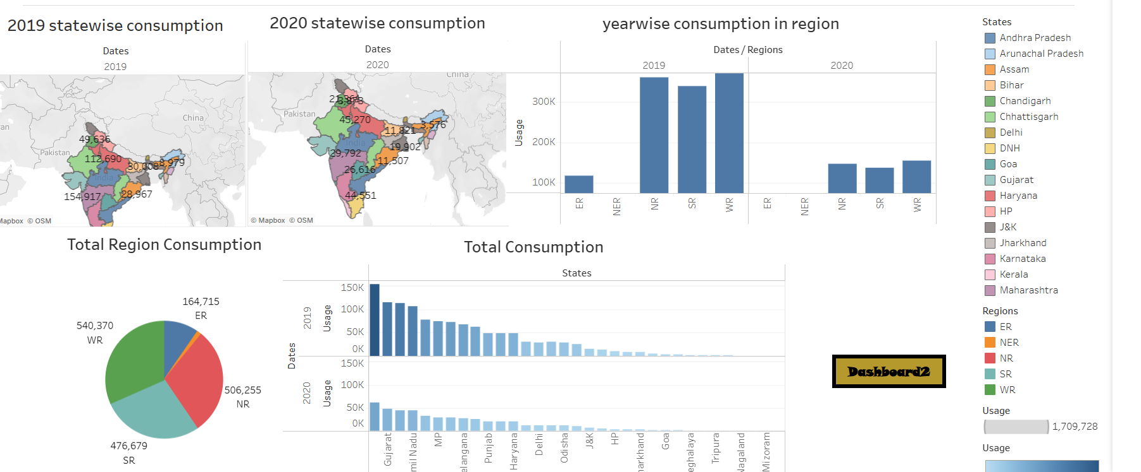No of Visualizations / Graphs –
6 | Story Design | 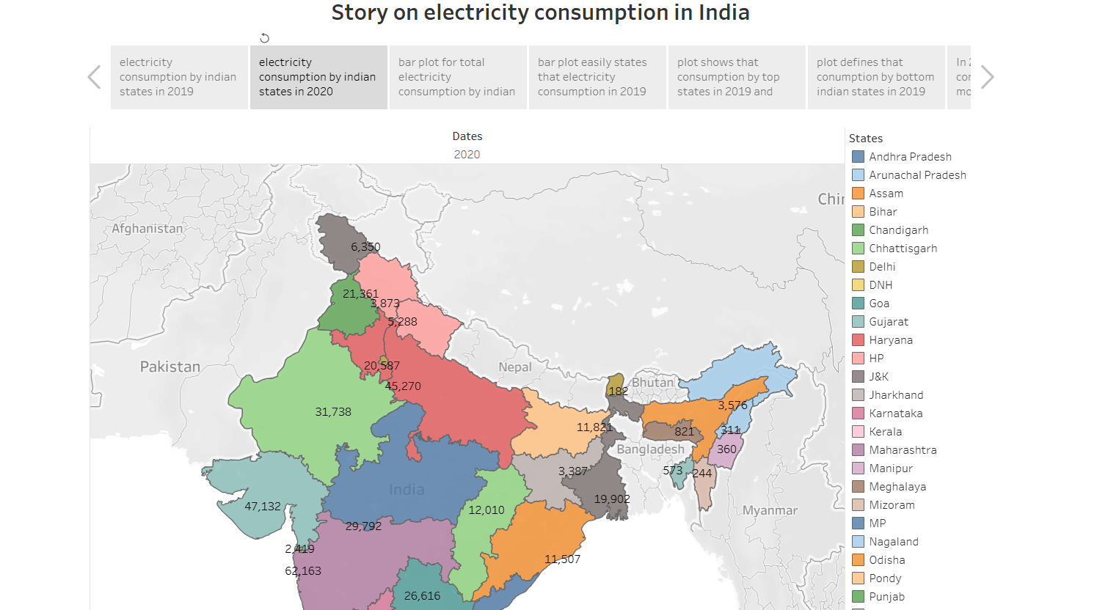No of Visualizations / Graphs –

